AIM: To draw a ER diagram for bank database.

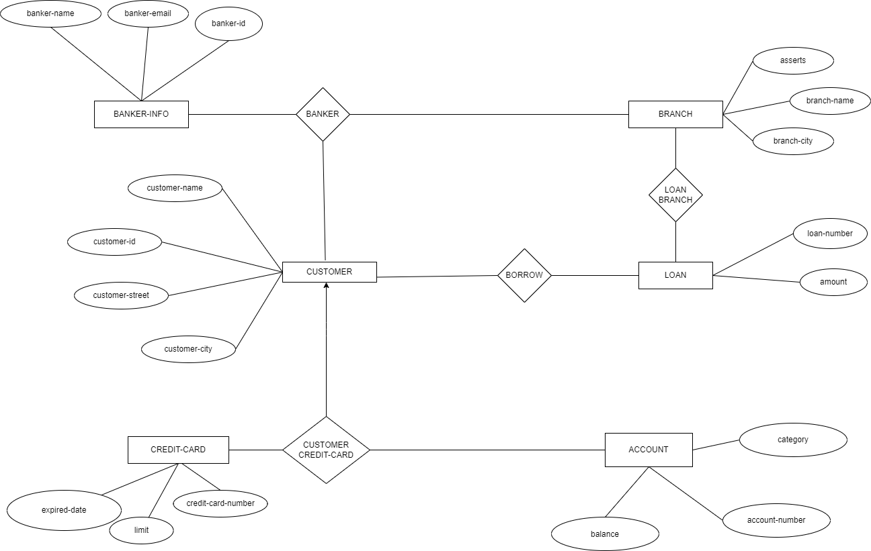

RESULT: ER DIAGRAM is successfully created